# **Phase 6: User Interface Development**

## Lightning App Builder

Created the ShopSmart App in App Manager. Configured branding, navigation, and utility bar. Assigned to administrator profile.

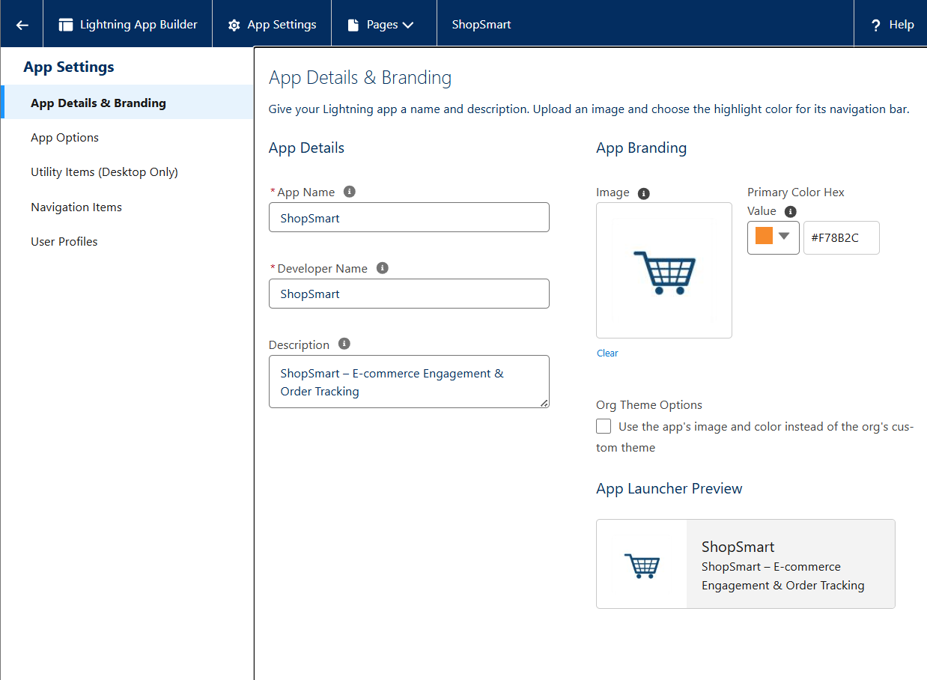

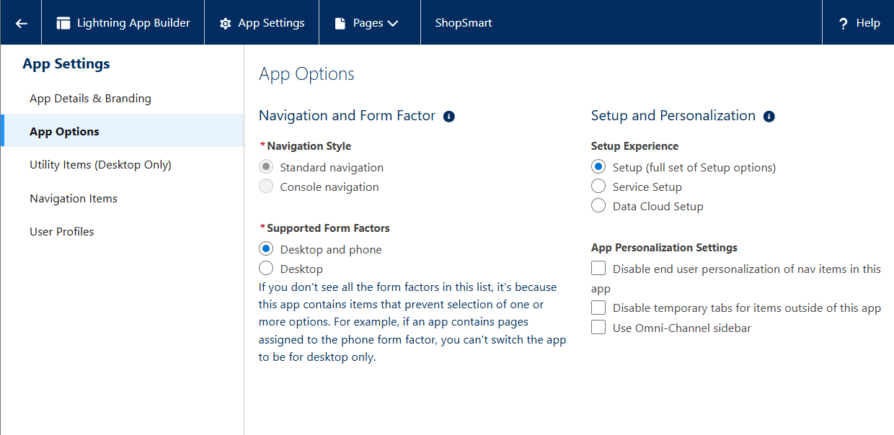

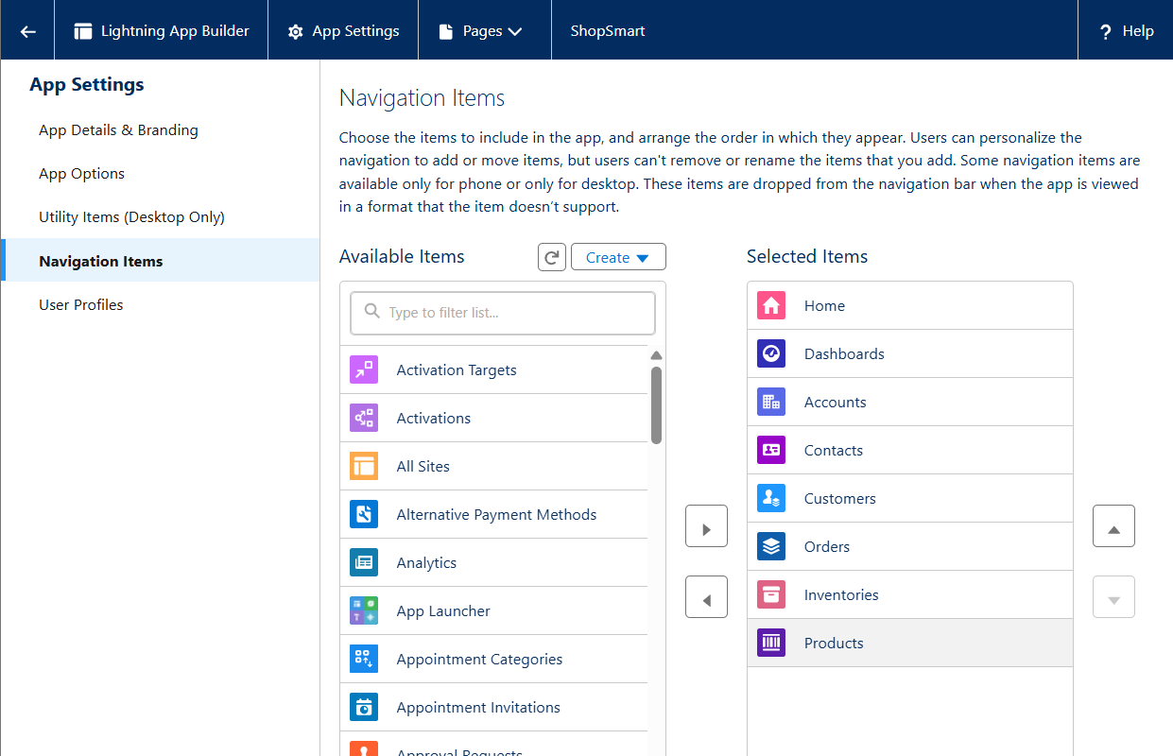

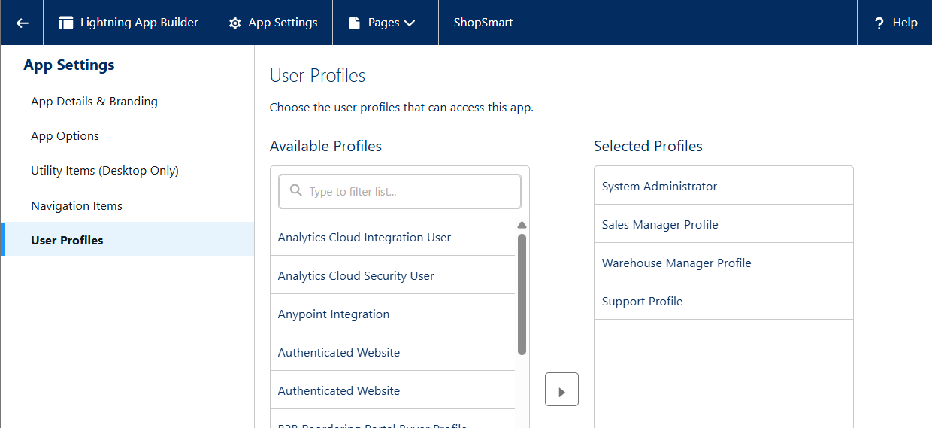

## Record Pages

Custom record pages built for Orders, Products, and Customers. Added Highlights Panel, Record Detail, and Related Lists components.

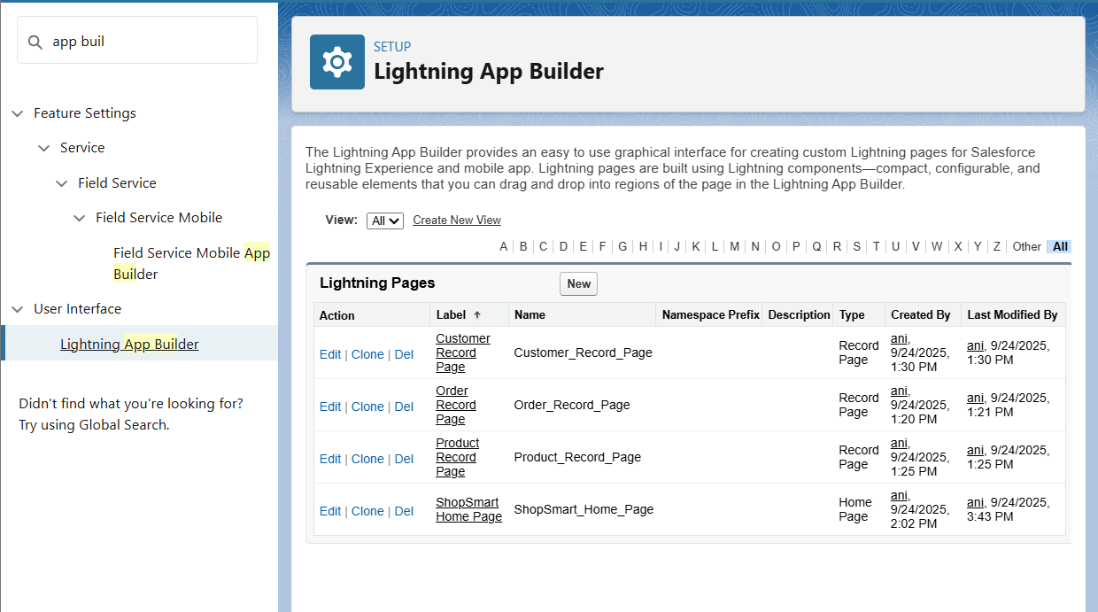

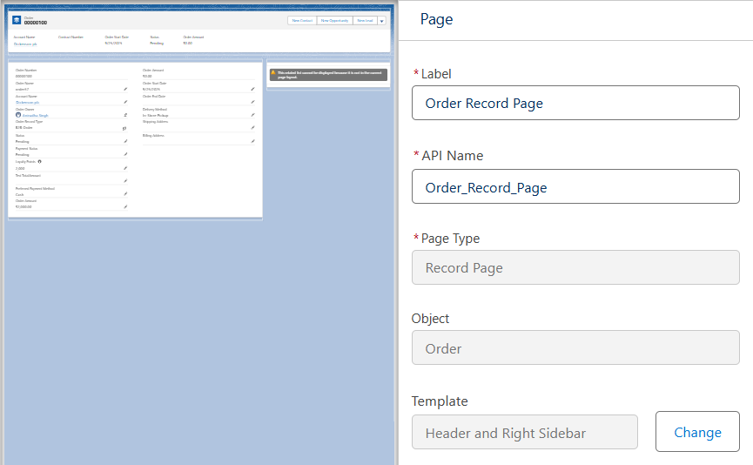

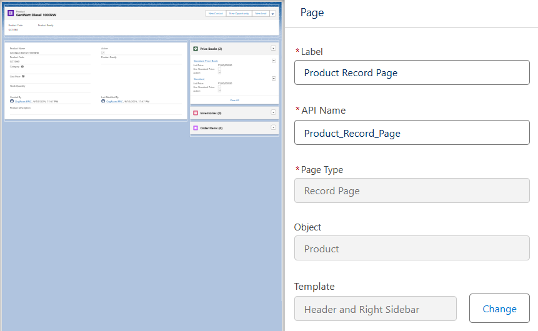

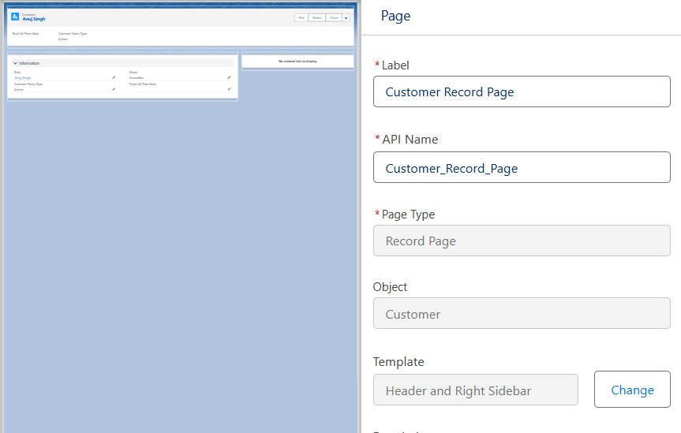

## Tabs

Tabs created/verified for Orders, Products, Customers. Added existing tabs like Inventories and Order Items into ShopSmart app navigation.  
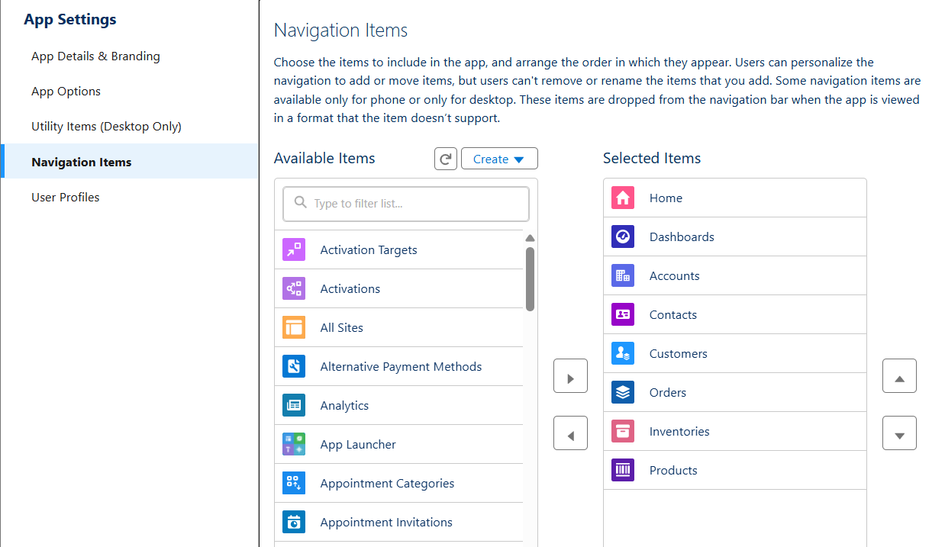



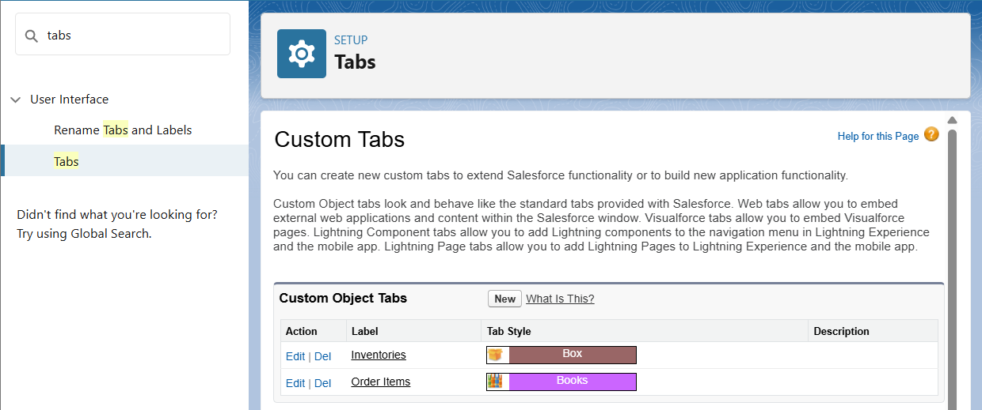

## Home Page Layouts

Designed custom Home Page using Lightning App Builder with Report Charts, List Views, Rich Text (welcome message), and Dashboard components.  


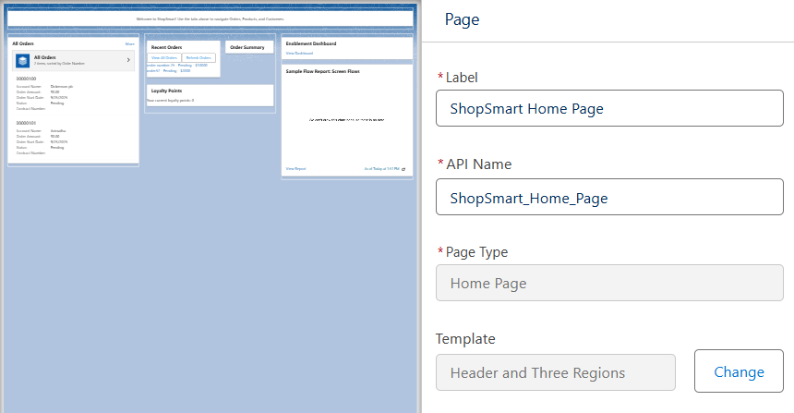

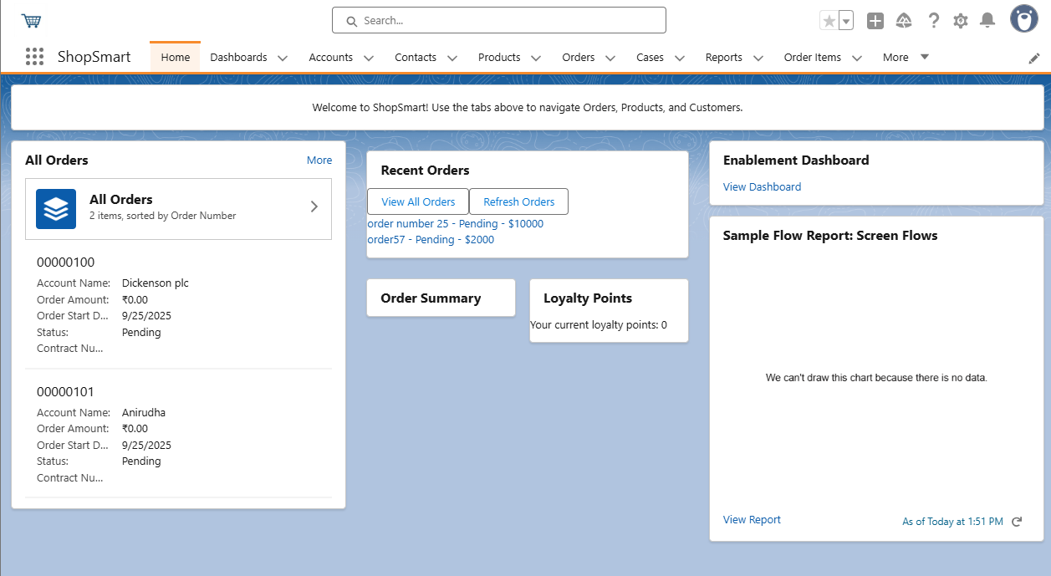

## Utility Bar

Configured Utility Bar with quick access to Recent Items, Notes, List Views, and Report Charts.

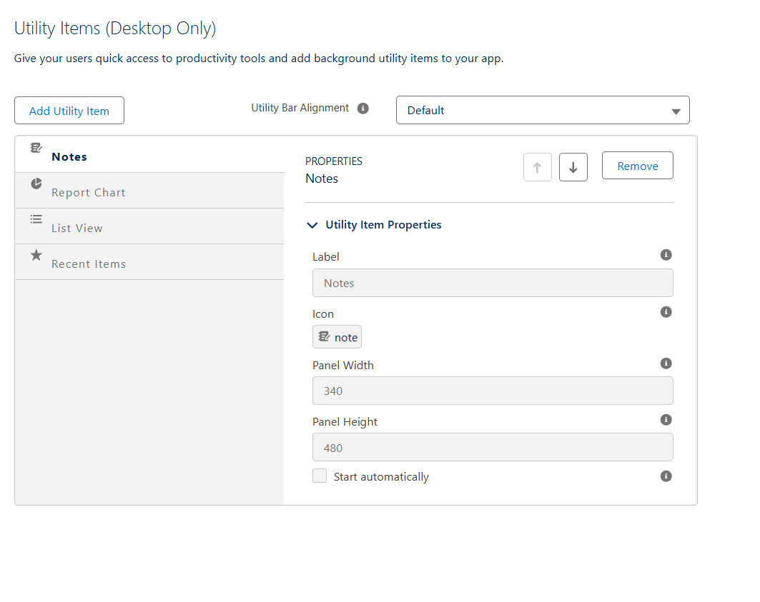  
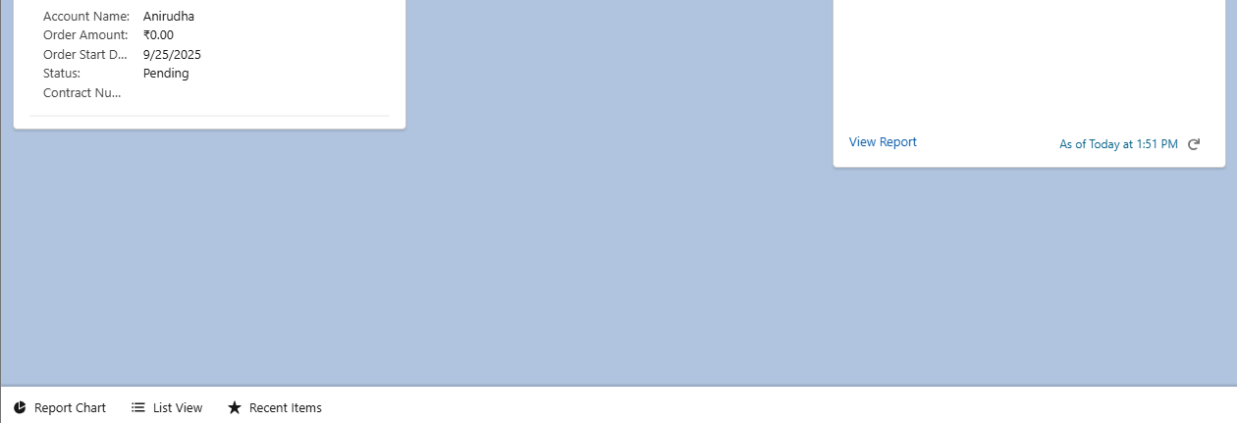

## LWC (Lightning Web Components)

Developed LWCs: recentOrders, orderSummary, loyaltyPoints. Purpose: Display recent orders, inline summaries, and loyalty points.

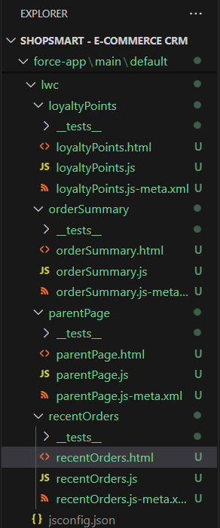

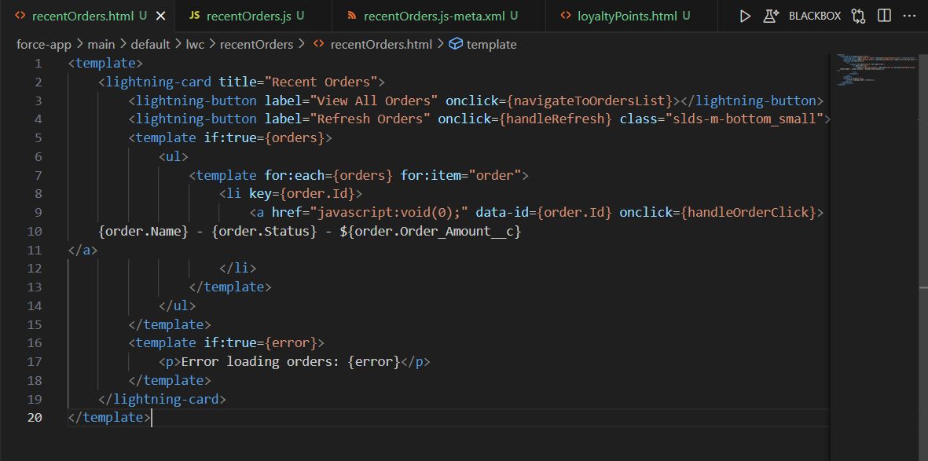

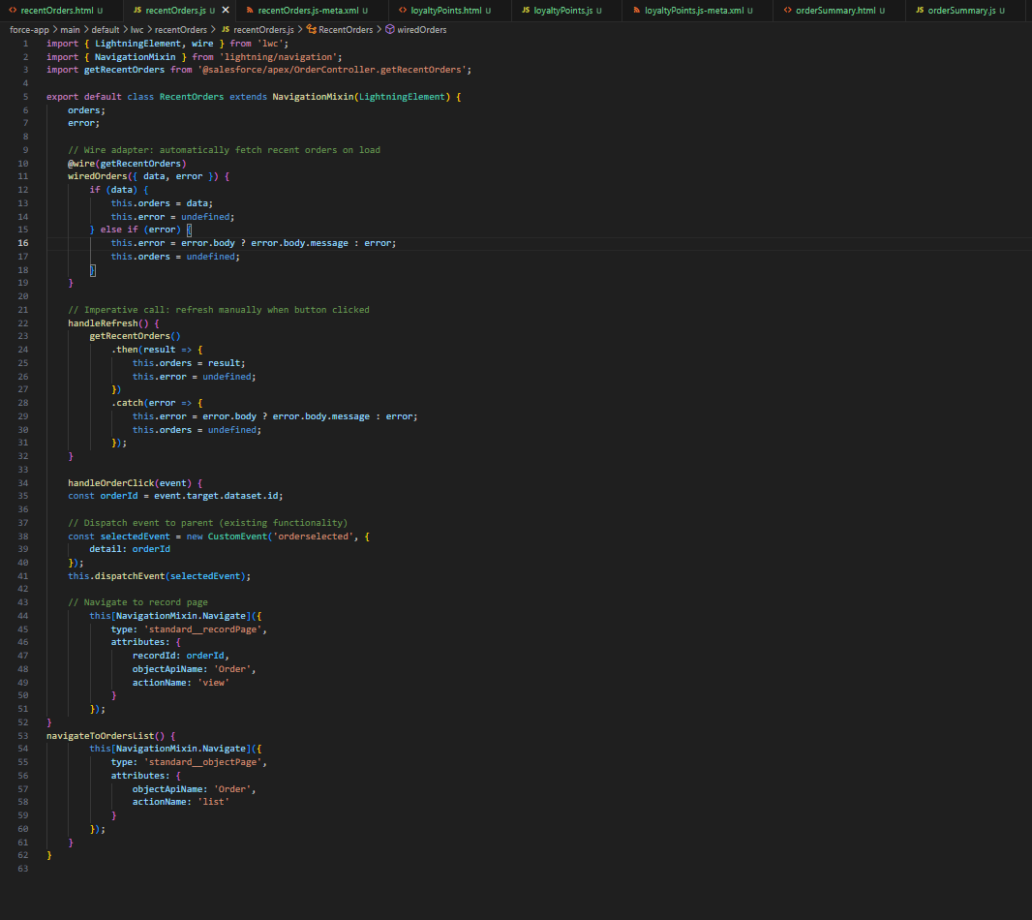

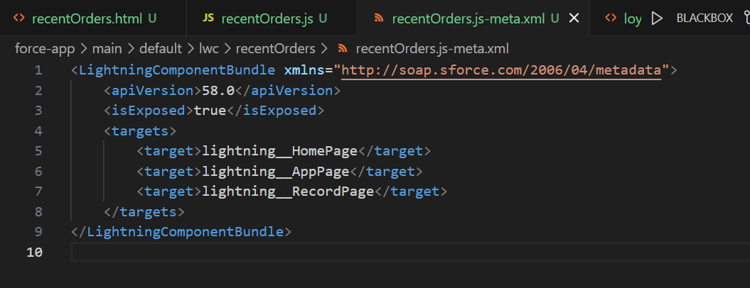

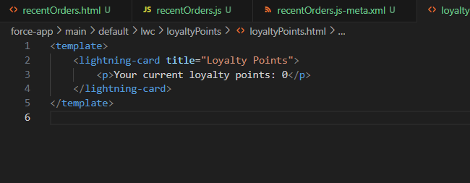

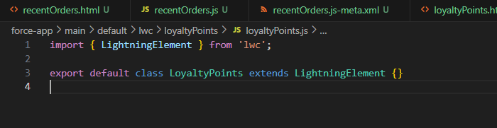

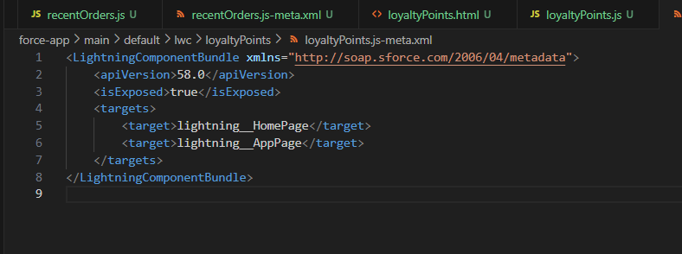

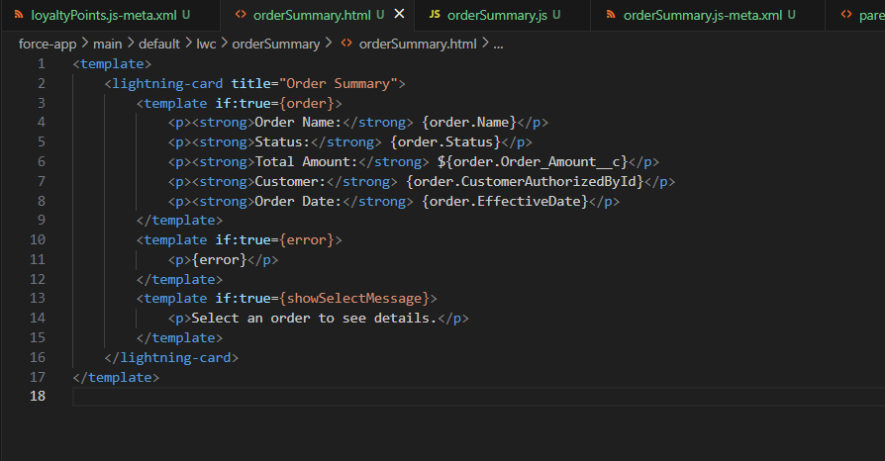

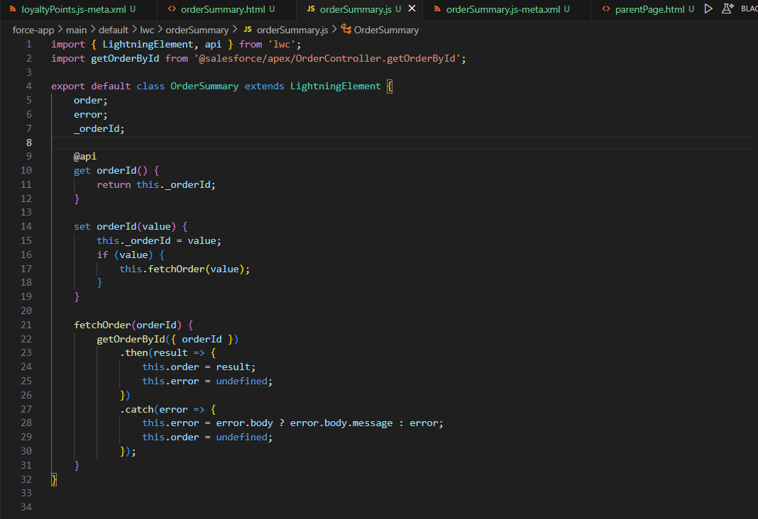

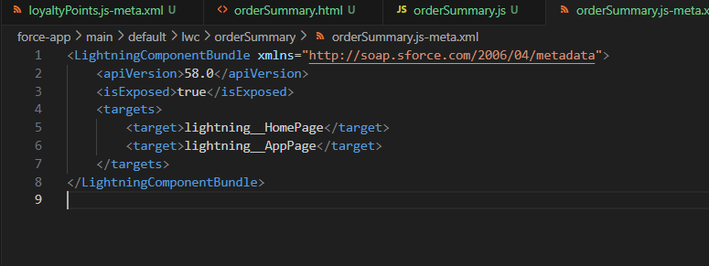

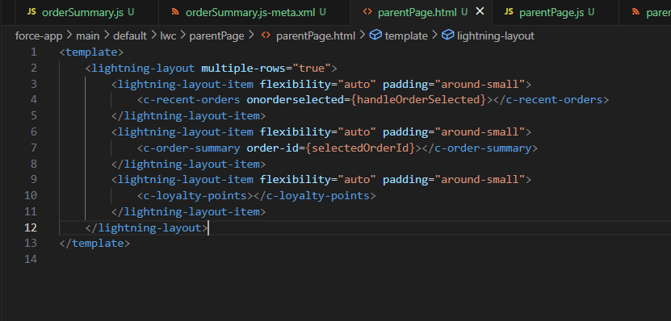

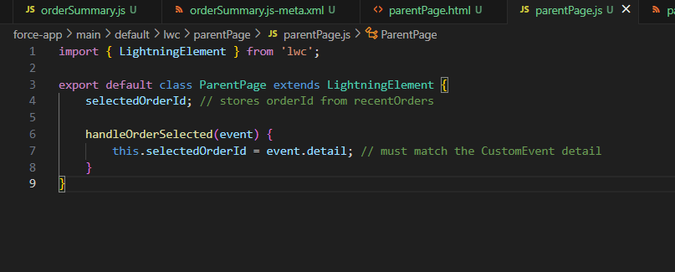

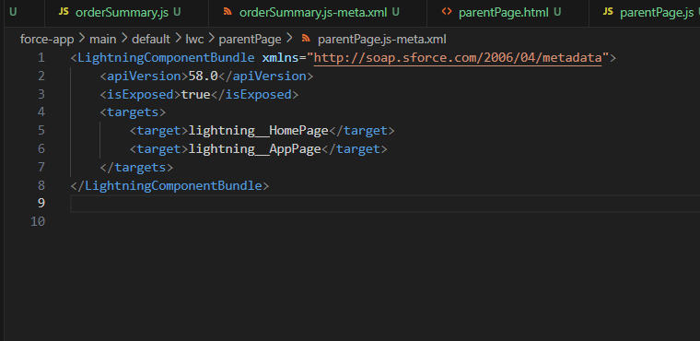

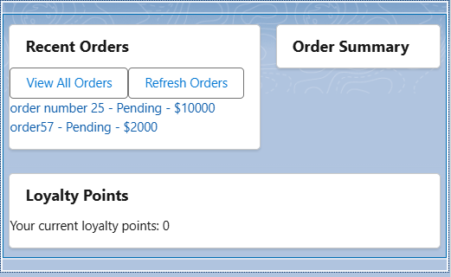

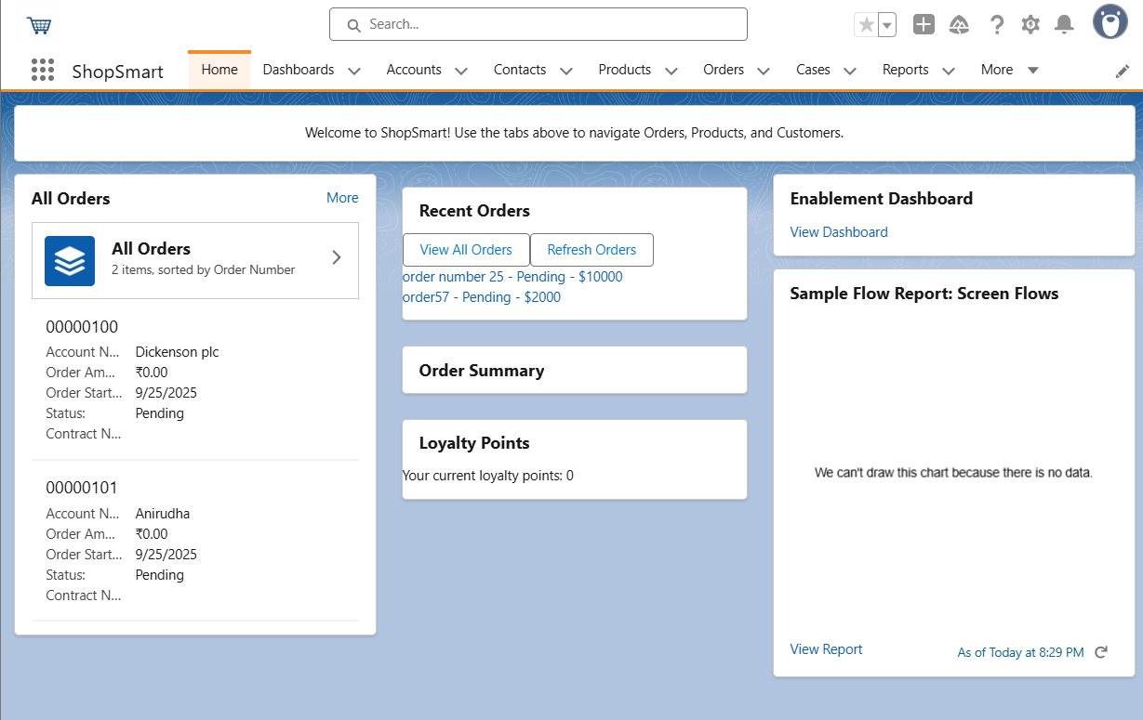

## Apex with LWC

Created Apex class OrderController for retrieving recent orders and order details. Integrated LWCs with Apex using @wire and imperative calls.  
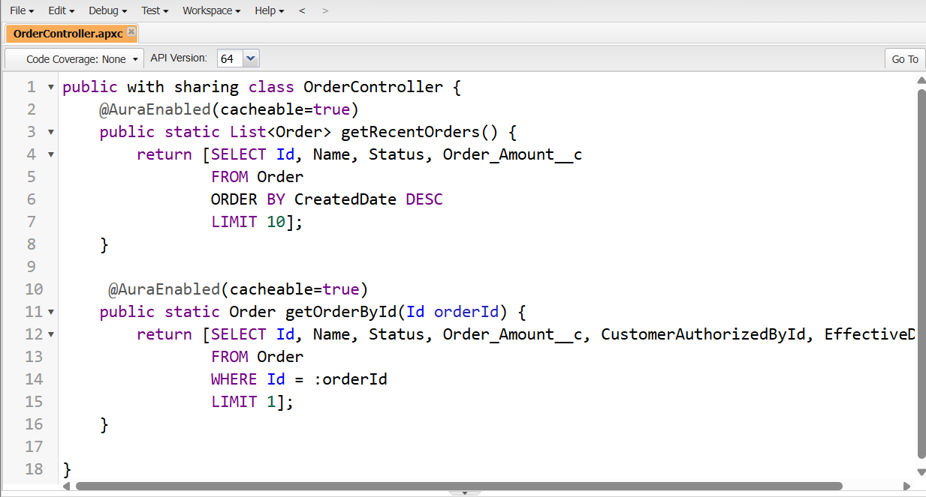

## Events in LWC

Implemented CustomEvent communication: recentOrders dispatches 'orderselected', parentPage receives and passes orderId to orderSummary.  






## Wire Adapters

Used @wire for reactive data loading in recentOrders. Ensures recent orders automatically display on load.



## Imperative Apex Calls

Added imperative Apex calls to refresh data on demand, e.g. refresh button in recentOrders, order detail fetch in orderSummary.  


## Navigation Service

Added NavigationMixin in recentOrders to navigate directly to record pages, list views, or external URLs.  
